Architectural Components – Resources

📦 What is Resources
# Source: AI Source: Provided by: [Data Path: Persons Table -> ID Column: 1, Name_En Column: Motasem Essam] -> From: [ChatGPT] on [1/23/2026]
In software architecture, Resources are reusable assets or objects that provide data, functionality, or services to the application. They are the building blocks that other components (Controllers, Services, ViewModels) rely on to perform tasks.
👉 Think of Resources as the shared tools, endpoints, or data providers your application consumes.

🔑 Responsibilities of Resources
# Source: AI Source: Provided by: [Data Path: Persons Table -> ID Column: 1, Name_En Column: Motasem Essam] -> From: [ChatGPT] on [1/23/2026]
- Provide data or content to the application
- Offer services or utilities (e.g., configuration, localization, API endpoints)
- Can be static or dynamic
- Ensure reusability and maintainability across components

Types of Resources in Software Architecture
# Source: AI Source: Provided by: [Data Path: Persons Table -> ID Column: 1, Name_En Column: Motasem Essam] -> From: [ChatGPT] on [1/23/2026]
- API Endpoint as a Resource
  - Represents external or internal services your app calls
  - Example: /api/users, /api/orders
- Configuration Resource
  - Centralized settings and constants used across the app
  - Example: { theme: 'dark', itemsPerPage: 20 }
- Localization Resource
  - Provides translations, messages, and language-specific content
  - Example: { en: { welcome: 'Welcome' }, es: { welcome: 'Bienvenido' } }
- Static Assets Resource
  - Images, CSS, JS, fonts, and other media files
  - Example: /assets/logo.png, /assets/styles.css
- Database Resource
  - Tables or collections that provide persistent data
  - Example: users, orders, products tables
- Model / Domain Resource
  - Domain objects or entities that represent business data
  - Example: User, Order, Product classes
- Service Resource
  - Shared utility or helper services (logging, authentication, caching)
  - Example: AuthService, EmailService, PaymentGateway
- Template Resource
  - Predefined layouts or UI components for consistent presentation
  - Example: HTML templates, reusable React components
- Event / Message Resource
  - Messages or events used in event-driven systems
  - Example: UserRegisteredEvent, OrderShippedEvent
- External Library / SDK Resource
  - Third-party tools or packages used across the app
  - Example: Lodash, Axios, Moment.js

🧱 Examples of Resources

1️⃣ API Endpoint as a Resource
# Source: AI Source: Provided by: [Data Path: Persons Table -> ID Column: 1, Name_En Column: Motasem Essam] -> From: [ChatGPT] on [1/23/2026]
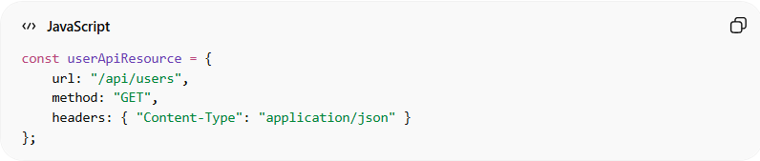
const userApiResource = {
url: "/api/users",
method: "GET",
headers: { "Content-Type": "application/json" }
};
- Can be reused by different services or ViewModels to fetch user data.

2️⃣ Configuration Resource
# Source: AI Source: Provided by: [Data Path: Persons Table -> ID Column: 1, Name_En Column: Motasem Essam] -> From: [ChatGPT] on [1/23/2026]
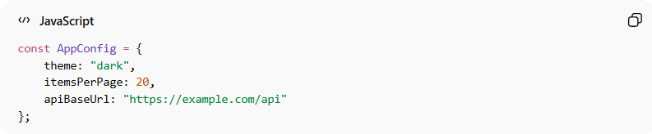
const AppConfig = {
theme: "dark",
itemsPerPage: 20,
apiBaseUrl: "https://example.com/api"
};
- Centralized config avoids hardcoding values in multiple places.

3️⃣ Localization Resource
# Source: AI Source: Provided by: [Data Path: Persons Table -> ID Column: 1, Name_En Column: Motasem Essam] -> From: [ChatGPT] on [1/23/2026]
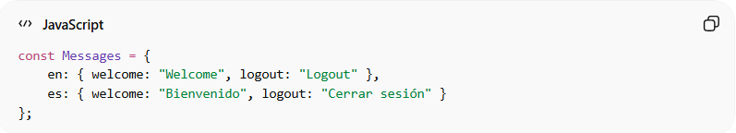
const Messages = {
en: { welcome: "Welcome", logout: "Logout" },
es: { welcome: "Bienvenido", logout: "Cerrar sesión" }
};
- Used to display text in multiple languages dynamically.

❌ Bad Example (Resources Mismanaged)
# Source: AI Source: Provided by: [Data Path: Persons Table -> ID Column: 1, Name_En Column: Motasem Essam] -> From: [ChatGPT] on [1/23/2026]
function getUsers() {
return fetch("/api/users"); // endpoint hardcoded everywhere
}
Problems:
- API endpoint is duplicated in multiple places
- Hard to maintain or update
- Breaks DRY principle

✅ Good Practices
# Source: AI Source: Provided by: [Data Path: Persons Table -> ID Column: 1, Name_En Column: Motasem Essam] -> From: [ChatGPT] on [1/23/2026]
- Centralize URLs, configs, messages, and shared utilities
- Avoid hardcoding inside Controllers or ViewModels
- Keep resources reusable and consistent
- Treat them as read-only shared assets whenever possible

🔄 Relation to Other Components
# Source: AI Source: Provided by: [Data Path: Persons Table -> ID Column: 1, Name_En Column: Motasem Essam] -> From: [ChatGPT] on [1/23/2026]
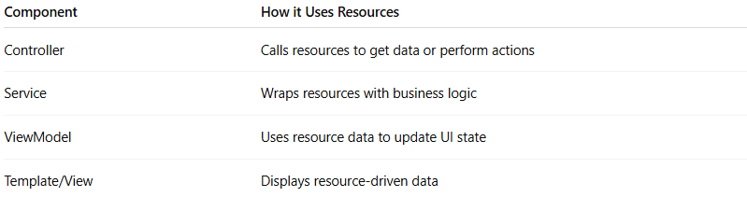
Component | How it Uses Resources
Controller | Calls resources to get data or perform actions
Service | Wraps resources with business logic
ViewModel | Uses resource data to update UI state
Template/View | Displays resource-driven data

💡 Summary:
# Source: AI Source: Provided by: [Data Path: Persons Table -> ID Column: 1, Name_En Column: Motasem Essam] -> From: [ChatGPT] on [1/23/2026]
Resources are shared assets or providers that supply data or functionality consistently across your application, keeping it modular, maintainable, and reusable.

